NAME Treepat Chantaurai

DATE 13 September 2021 Section J

**Report Sheet for Experiment 2: Newton’s Law**

Abstract

In this experiment, mass pulley system is used to investigate the Newton’s second law. Varying mass that attached to the smart cart which give the weight as acceleration. The result can be further implied to the static and dynamic friction before and after the smart cart starts to accelerate from stationary.

Introduction

Motion of an object by an applied force can be described by all three of the Newton’s laws. First when the force does not yet reach the threshold value where the static friction is still dominant, the net force acting on the object is zero, indicated by no acceleration occurring in either constant speed or no speed manner. Subsequently, when the object accelerates, its acceleration can be formulated by the ration of the net acting force in that axis over its inertia(mass). Finally, the third law can be applied with the Normal force, for instance, that has an equal value but opposite direction with the weight, acting on a different object.

Theoretical Background

When the object moves with an applied force, its acceleration can be described as:

$a=\frac{\sum{F}}{m}$ => $\sum{F}=ma$

Where F is the net applied force (Newton: kgm/s2), m is mass(kg), a is the acceleration(m/s2).

On the surface of the Earth, there is a gravitational field due to the mass of the earth, acting toward the very center of the planet. During a free-fall of an object due to this field, meaning no air resistance, no heat loss, the acceleration of it will be equal to 9.81 m/s2. The data from the projectile motion from the 1st experiment could rigorously confirm this. In y-direction of the projectile trajectory, there is a constant gravitational force acting on the object, making it accelerates and decelerates illustrated in the slope of velocity-time graph in Figure 1

Figure 1 displays the y_velocity vs. time in an angled projectile motion

Furthermore, in a system of object such as one depicted in the Figure 2 where mass(m) is free-falling due to gravity(g) and the attached rope drag the smart cart (mass M) altogether with the same acceleration(a). With above information, the acceleration can be determined as follows:

$$ΣF=ma$$

$$mg=\left(M+m\right)a$$

$$\frac{m}{M+m} g=a$$

$$\frac{m}{M+m} g= \frac{d^{2}x}{dt^{2}}$$

$x= \frac{m}{M+m} g (\frac{t^{2}}{2}$)

Methods

Part A

1. Set up the experiment shown in the Figure 2 with a rubber band to decelerate the smart cart and move the smart cart as far as possible
2. Attach mass hanger with the opposite side if the rope
3. Release the cart while record the data
4. Repeat by varying different weight of the attached mass including 9.9, 20.0, 30.2, and 40.2 gram
5. Analyze data of Force vs position by selecting the range of linear force occurring

Part B

1. Repeat Part A with a mass bar attached on the smart cart

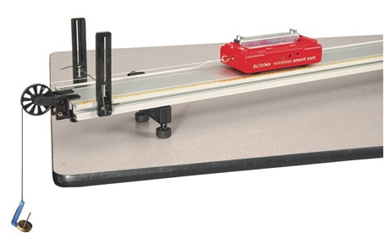

Figure 2 displays the experiment set-up of the smart cart, the rope, and the attached mass

Results

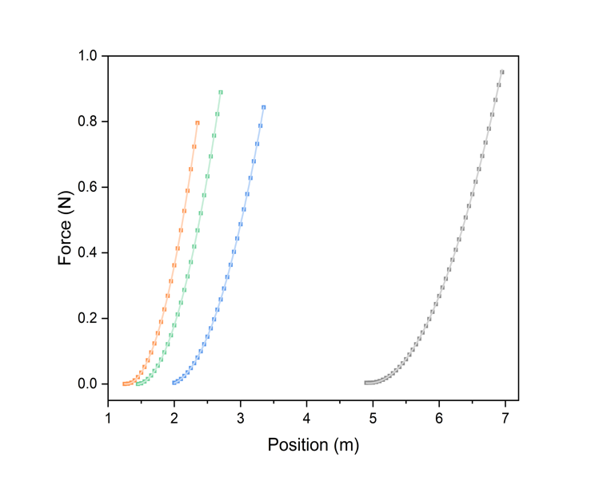

Position (m)

Time (second)

Figure 3 displays the relationship between position and time of a) without mass bar and b) with mass bar with the attached mass ranging from 9.9, 20.0, 30.2, and 40.2 gram from left to right

|  |  |  |  |  |  |  |  |  |
| --- | --- | --- | --- | --- | --- | --- | --- | --- |
| M (kg) | 0.2492 (without mass bar) | | | | 0.5049 (with mass bar) | | | |
| m (kg) | 0 | 0.0251 | 0.0353 | 0.0453 | 0.015 | 0.0251 | 0.0353 | 0.0453 |
| F_avg (N) | 0.8985 | 0.99 | 1.0828 | 1.1277 | 0.9155 | 1.0094 | 1.0881 | 1.1672 |
| a (m/s2) | 0.236 | 0.400 | 0.552 | 0.690 | 0.286 | 0.373 | 0.209 | 0.668 |
| Ma (N) | 0.058811 | 0.09968 | 0.137558 | 0.171948 | 0.144401 | 0.188328 | 0.105524 | 0.337273 |
| mg (N) | 0.14715 | 0.246231 | 0.346293 | 0.444393 | 0.14715 | 0.246231 | 0.346293 | 0.444393 |

Table 1 summarizes the forces of the experiment in two cases: without mass bar, and with mass bar

Discussion

The meaning of the slope of FN-Fm and Fg-Fm  is the relationship between the tension and the varied weight which can verify the validation of the Newton’s second law

Conclusion

According to the experiment, the acceleration can be found by fitting quadratic equation onto the position time graph. By comparing the measurement and calculation, the value is quite close to the theoretical one. There might be some error occurring from the force sensor, yet, the relationship between tension, acceleration, and mass are not affected

References

1. <https://genphylab.kaist.ac.kr/labs/general-physics-lab-1/newton's-2nd-law/manual>

